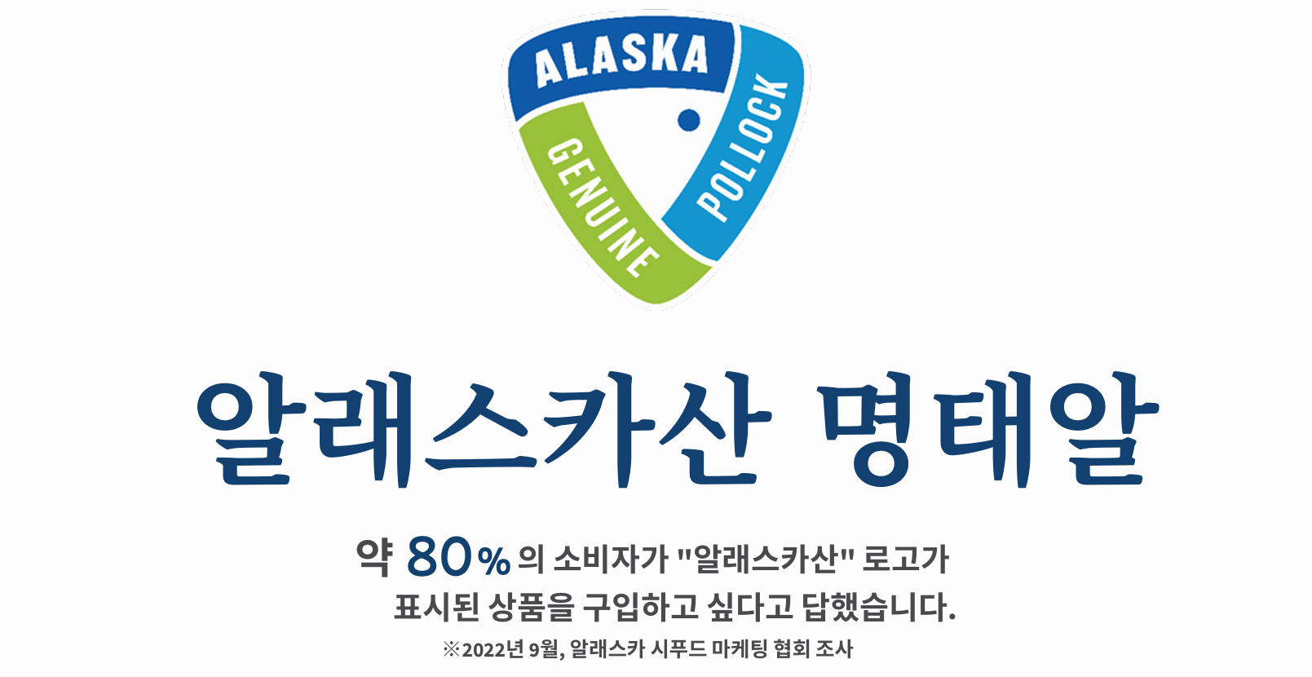

**Alaska Pollock Roe**

Consumers indicated a preference to purchase products displaying the **"Made in Alaska" logo**  
*(According to research conducted by the Alaska Seafood Marketing Institute, September 2022.)  
  
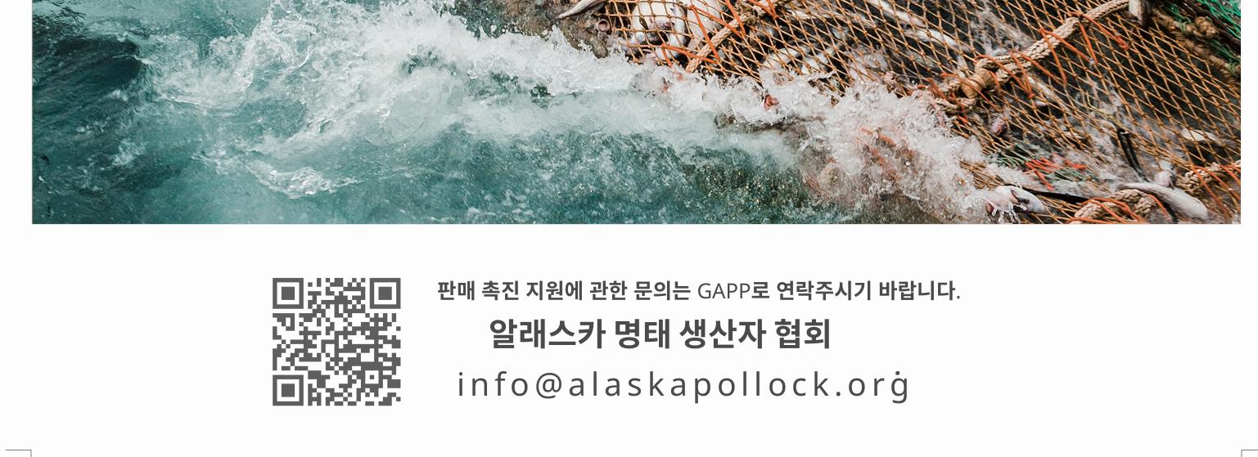*For inquiries regarding promotional support, please contact GAPP:

**Genuine Alaska Pollock Producers**  
info@alaskapollock.org