**  
  
“Products labeled ‘Alaska’ Increase Consumer Purchase Intent”**

**Consumer research reveals the appeal of Alaska seafood.  
  
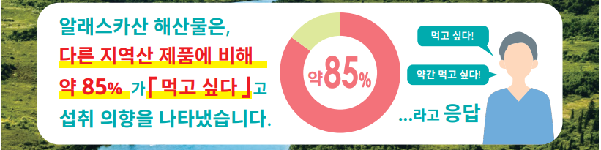**

Seafood from Alaska shows **approximately 85%** of consumers expressing a desire to eat it,  
**compared to products from other regions**.  
  
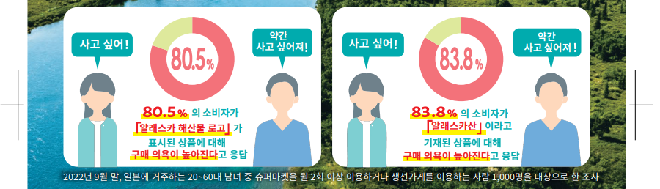

**Survey Results**

* **80.5%** of consumers said they are more likely to purchase products labeled with the **“Alaska Seafood logo.”**
* **83.8%** of consumers said they are more likely to purchase products labeled as **“Alaska origin.”**

(*Survey conducted in September 2022 among 1,000 Japanese consumers aged 20–60 who shop at supermarkets at least twice a week and regularly consume seafood.*)

**  
  
  
Why not create a product using 100% Alaska-sourced ingredients?**

If you develop a product using Alaska pollock roe, here’s what you gain:

**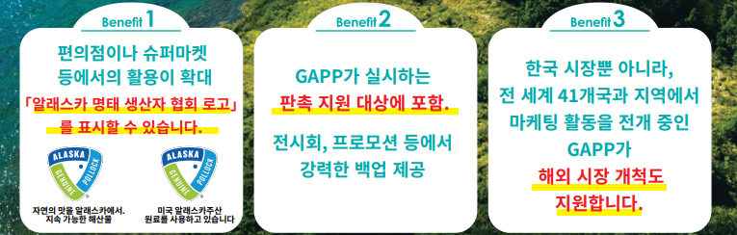  
  
Benefit 1**

**Expanded availability** in convenience stores, supermarkets, and more.  
You can promote with the **GAPP logo** to the label.  
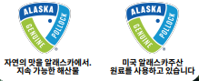  
(Left) Taste Nature from Alaska, Sustainable Seafood  
(Right) Made with ingredients sourced from Alaska, USA.

**Benefit 2**

Eligible for **match funding** through GAPP.  
Receive strong support for trade shows, promotions, and more.

**Benefit 3**

GAPP supports **market development not only in Korea** but in over 41 countries worldwide.  
Marketing support is also available for **overseas expansion**.

**Genuine Alaska Pollock Producers (GAPP)**

* Mail: info@alaskapollock.org
* Instagram: wildakpollock
* Facebook: <https://www.facebook.com/wildAKpollock>