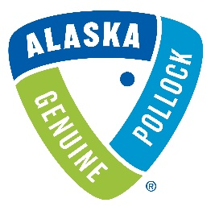
GAPP SENSITIVE PHOTO AND VIDEO ASSET REQUEST PROCESS
The Association of Genuine Alaska Pollock Producers (GAPP) has a variety of photo and video asset files it has as a result of various video and photo shoots in Alaska that are available for GAPP members that depict more sensitive industry issues such as incidental catch, quality control on the processing line, and other issues that aren’t suitable for marketing purposes and are not placed in the GAPP asset library open to members. However, these files may be useful to GAPP members for training or other appropriate purposes and are available upon request from members.
Please see the below categories for images that GAPP has available.
- Incidental Catch (i.e., incidental catch segregation, disposal, etc.)
- Quality Control (i.e., bone detection, parasite removal, etc.)
If you would like access to these files, please email Lydia Moore at lydia.moore@alaskapollock.org or Craig Morris at craig.morris@alaskapollock.org.
Thank you.
---

