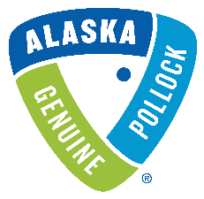

Proposal Submission Form (Attachment A)

All applicants should include the following information, providing an overview of your proposal.
Please send this completed form to Christine Durkin at Christine.durkin@alaskapollock.org no later than July 20th, 2021.

1. | Name of promotion/project and description:
2. | Promotion/project start date:
3. | Promotion/project completion date:
4. | Total Project Spend: (in USD)
5. | Funding Amount Requested from GAPP (in USD):
6. | Any additional funds that are being contributed from other sources (in USD):
7. | Wild Alaska Pollock Material(s) or Product Used:

8. | Raw Material Supplier. Is it a new or existing contract?
9. | Is this partnership a new-to-market product or existing product? If existing, is this a conversion to Wild Alaska Pollock from another fish?
10. | Target market:
11. | Geographic distribution/coverage:

12. | Please describe the context and size of the opportunity and any fact-based reasons to believe that the program/product will be successful, such as,  - Concept or Product tests scores  - Consumer/Customer/Distributor feedback  - Third party expert opinion  - Relative historical experience (with Wild Alaska Pollock/other species/protein)
13. | Describe the goals for this partnership, expressed as SMART Objectives.  - Specific - objective is clear and defined  - Measurable – provides specific data or metrics driven targets (quantifiable and verifiable)  - Achievable – is accomplishable with available resources  - Relevant – is aligned to GAPP’s objectives & strategy  - Time-Based – has a realistic timeframe or end date

14. | Program specific metrics: What will be collected; how will results be shared with GAPP. (Please see Attachment B for examples of information GAPP wishes to collect).
15. | Company Name & Contact (Email & Phone #)

