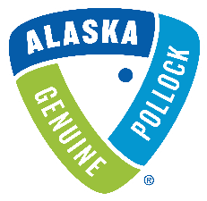

Proposal Submission Form (Attachment A)

All applicants should include the following information, providing an overview of your proposal.
Please send this completed form to Christine Durkin at Christine.durkin@alaskapollock.org no later than July 20th, 2021.

Name of promotion/project:

Promotion/project start date:

Promotion/project completion date:

Total Project Spend: (in USD)

Funding Amount Requested from GAPP (in USD):

Any additional funds that are being contributed from other sources (in USD):

Wild Alaska Pollock Material(s) or Product Used:

Raw Material Supplier. Is it a new or existing contract?

Is this partnership a new-to-market product or existing product? If existing, is this a conversion to Wild Alaska Pollock from another fish?

Target market:

Geographic distribution/coverage:

Please describe the context and size of the opportunity and any fact-based reasons to believe that the program/product will be successful, such as,

  - Concept or Product tests scores
  - Consumer/Customer/Distributor feedback
  - Third party expert opinion
  - Relative historical experience (with Wild Alaska Pollock/other species/protein)

Describe the goals for this partnership, expressed as SMART Objectives.
  - Specific - objective is clear and defined
  - Measurable – provides specific data or metrics driven targets (quantifiable and verifiable)
  - Achievable – is accomplishable with available resources
  - Relevant – is aligned to GAPP’s objectives & strategy
  - Time-Based – has a realistic timeframe or end date

Program specific metrics: What will be collected; how will results be shared with GAPP. (Please see Attachment B for examples of information GAPP wishes to collect).

Company Name & Contact (Email & Phone #)

